Ideation Phase

Define the Problem Statements
Date | 19 September 2026
Team ID | Shaik Irshad – 238W1A4256
Project Name | Automated Network Request Management in ServiceNow
Maximum Marks | 2 Marks

Customer Problem Statement
A well-articulated problem statement allows the project team to design the ideal solution for the challenges the requester faces when raising a network service request. It captures the requester's situation, goal, obstacle, root cause and resulting emotion in a single, structured line.
PS-1: Manual, Inconsistent Request Submission
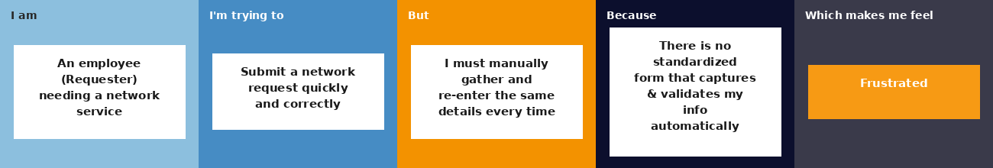
PS-2: Lack of Approval Visibility
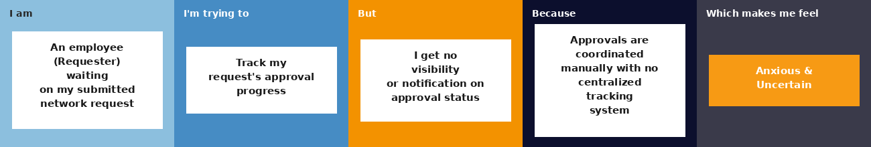

Problem Statement Table
Problem Statement (PS) | I am (Customer) | I'm trying to | But | Because | Which makes me feel
PS-1 | an employee (Requester) who needs a network service | submit a network request quickly and correctly | I have to manually gather and re-enter the same details every time, with no way to confirm the request went in correctly | there is no standardized ServiceNow form that automatically captures and validates my information | frustrated
PS-2 | an employee (Requester) waiting on a submitted network request | track the approval progress of my request | I get no visibility or automatic notification on where my request stands | approvals are coordinated manually with no centralized system for tracking status and updates | anxious and uncertain

Problem, Need & Solution Summary
Problem: Employees who need network-related services face a fragmented, largely manual request process where information must be collected consistently, approvals coordinated separately, and request progress is difficult to track.
Need: A standardized IT service request workflow is needed to collect request information, validate it, automate backend processing, and manage approval status in one system.
Solution: A ServiceNow Service Portal-based Network Request catalog item, connected to a custom backend table and a Flow Designer automation, that handles record creation, email notification, approval, and status updates end to end.

